# Part 2> 1st item (relisten and write this script)

Four steps to critique an art:

e.g. Here is an **expressionist** paining:

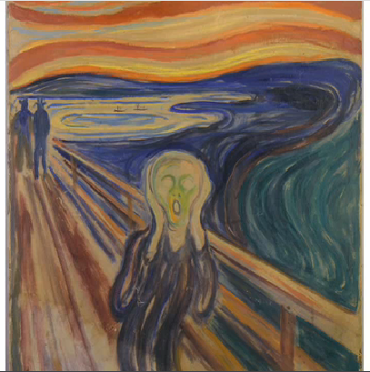

* Description:
  + State the name of the work,
  + the artist (e.g. impressionist painter, expressionist painter),
  + the media, e.g. ? oil on canvas?
  + what it looks like, be **objective**: colors, lines, shapes
* Analysis (most important part of the critique):
  + how the elements in the art are organized
  + how they complement one another
  + the movement, variety, balance, contrast,
  + what the artist wanna emphasize => the painting evokes such an intense emotion in 2 things: the line and color. //evoke 激起了强烈的情感。
    - e.g. ( line ) The **wavy lines** of the sky and the landscape **contrast intensely with** the straight lines of the bridge
    - e.g. ( color ) The bold **streaks/stripes** of yellow and red **stand out against** the deep **hues** of blue and green. //pastel color淡雅的, soothing color缓和的颜色
    - e.g. ( line ) The strong **diagonal** of the bridge moving out towards the viewers, the rapid **swirling**打旋的 motion of the landscape(风景), and the wild colors **all combine to create an image** of chaos and anxiety => the conclusion.

**(In a nutshell)** The motion and chaos of the colors and lines create an image of noise and upset, and panic.

* Interpretation:

For the interpretation, you should describe what think the artist was trying to say with the work.

The subject, the terrified person, is alone on the bridge and consumed by panic and fear, sort of in a dreadful situation.

The **vastness**广阔宽广 of the sky and the bridge, which surround the person, give this painting a feeling of alienation and loneliness, while at the same time conveying chaos and emotional intensity强烈紧张.

Although it was painted in 1893, it makes me think of the stress and burden that is felt in the modern world, something like I’m an unhappy workaholic in the **pressure-cooker working environment**.

The author may be trying to express the idea of loneliness in a crazy, dangerous, stressful, intense, and chaotic world. The man is totally alone and **consumed** by fear //consume: destroy completely.

* Judgement: The last step in art critique is the judgement.

This is when you say whether it’s a success or failure in your perspective. This is your opportunity to really express your opinion of the art.

This painting evokes feelings of fear, intimidation 恐吓, loneliness, and **despair**. When I look at it, I’m **overwhelmingly**强烈的 touched by his terror, his panic, the **overwhelming** feels of stress and intensity, but also his **desperation**.

I can relate to his feeling, although it’s scary/frightened. Well, In a nutshell, I’m really full of admiration of this artist who is so skilled at evoking such an emotional response.

I think the painting is fascinating and **deserves** you to look at. Munch has successfully created a composition which conveys a universal emotion, a feeling that can be **discerned**/recognized and understood by all. I can almost hear that terrifying scream.

Next time, you’re admiring art at a gallery or museum, remember the critique strategy: description, analysis, interpretation, and finally the judgement.

## Words:

* **(the painting is) too busy: 太繁杂了**
* **daring /ˈdɛərɪŋ/**

1.ADJ People who are daring are willing to do or say things which are new or which might shock or anger other people. 大胆的 e.g. Well, this architecture is **spectacular** 壮观and **daring** 大胆的 e.g. Bergit was probably more **daring** than I was. 伯杰特可能比我胆子还大。

2.ADJ A **daring** person is willing to do things that might be dangerous. 英勇的勇敢的 e.g. His daring rescue saved the lives of the youngsters. 他英勇的救援行动挽救了那些少年的生命。

3.N- **Daring** is the courage to do things which might be dangerous or which might shock or anger other people. 胆量; 鲁莽 e.g. His **daring** may have cost him his life. 他的**鲁莽**差点要了他的命

## Types of painting

|  |  |
| --- | --- |
| 印象主义，印象派 | [ɪm'preʃənɪzəm]  impressionism   1. a style of painting used especially in France in the 19th century **which uses colour instead of details** of form to produce effects of light or feeling   印象主义，印象派〔不拘泥于细节，而**以色彩来营造光线** 或感觉效果的绘画风格，尤盛行于19世纪的法国〕   1. a style of music from the late 19th and early 20th centuries that produces feelings and images by the quality of sounds rather than by a pattern of notes 印象主义，印象派〔以音色而不是旋律来产生感觉和意象的音乐风格，盛行于19世纪末及20世纪初〕       Impressionist: adj) [ɪm'preʃənɪst,ɪm'preʃənəst]  1. someone who copies the speech or behaviour of famous people in order to entertain other people 模仿名人的滑稽演员  2. someone who uses impressionism in the paintings or music that they produce 印象派画家；印象派作曲家 [impressionist painters 印象派画家] |
| 〔绘画、文学或音乐的〕表现主义 | [ɪk'spreʃənɪzəm] expressionism: a style of painting, writing, or music **that expresses feelings** rather than describing objects and experiences    * Expressionist n/adj, expressionism: 表现派, 表达常常夸大或强烈的内心情感。许多 expressionists 使用抽象的形状作画。[**表现派画家expressionist painters; 表现主义运动the expressionist movement]**   E.g. Munch was one of the great **expressionist painters**.  E.g. De Kooning, one of the most famous **expressionists**, used abstract shapes to represent human body parts. |
| 立体派[主义]; 立体(几何图形)〔20世纪的一种艺术流派，以几何图形来表现主题〕 | cubism ['kjuːbɪz(ə)m]: **geometric shapes**; influenced by African tribal art; n. a 20th-century style of art, in which objects and people are represented by geometric shapes  [词条图片](javascript:;)  e.g. Which painting would best represent **cubism**?  * **a portrait** of a woman with a triangular nose. (Yes, this one because “triangular nose” is a geometric shape  * **a still life** of a soda pop bottle that is extra large  * a **landscape** of the countryside in **vivid vibrant green鲜绿色**. |
| 通俗艺术，大众艺术 | Pop art: 通俗艺术，大众艺术〔表现普通事物的一种艺术，流行于20世纪60年代〕  bring art to the people; merging with **commercial products广告商品**. a type of art that was popular in the 1960s, which shows ordinary objects, **such as advertisements,** or things you see in people’s homes |
| 静物写生 | **[ still life ]** a picture of an arrangement of objects, for example flowers or fruit    E.g. I love **still life**, especially if they have food and wine.  我喜欢 静物画,特别是有食物和酒的作品  e.g. Even before **a still life**, like an apple or a bottle, it is surprising to suddenly discover a shape, aprofile, or a color.  即使面对着静物，像一个苹果或一个瓶子。当你突然发觉它的形状、轮廓或颜色中的美感，这也是很令人惊奇的。 |

## Description

要 **critique**（评论）一幅作品，你需要对它进行describe。**使用类似表达进行 objective（客观的）说明**, e.g. shapes, lines, colors

|  |  |
| --- | --- |
| **Line** helps lead your eye around the painting. | 线条有助于引导目光观看画作。 |
| **Shape** is important to this painting; it's all rectangles and squares. | 形状对这幅画很重要，全部由长方形和正方形构成。 |
| **Form** describes the height,width and depth of something. | 轮廓描述事物的高度、宽度和深度。 |
| Painters use **perspective**透视法 to show **distance** and **depth**. | 画家用**透视法**显示距离和深度。 |

## Analysis ( Part2 > 2nd item)

在分析一幅画时，介绍how these elements (line, color, shapes, these objective elemetns) of a painting are organized or how they complement one another, e.g. whether there are movement, contrast ?。

|  |  |
| --- | --- |
| how these “objective” elements (line, color, shapes, these objective elemetns) of a painting are organized: | |
| The lines in the background **move toward** you directly. | 背景中的线条直接朝你移动。 |
| Abstract circles **combine to create** a floral image – or perhaps an army of UFOs. **//floral and fauna** | 一个个抽象的圆圈组成花卉图案，或者是一大群不明飞行物。 |
| how these “objective” elements complement one another, e.g. whether there are movement, contrast ? | |
| The reds **blend with** the pinks and browns. | 红色与粉色和褐色**融合在一起**。 |
| The intense colors **stand out against** the deep black background. | 鲜艳的色彩**在<*深黑背景>*的映衬下格外醒目**。 |
| The lines of the sky are a **sharp contrast to** the straight lines of the bridge. | 天空的线条**与<*那座桥的直线>*形成鲜明的对比**。 |

## Interpretation

当你在 **interpret**一幅画时 = **陈述你认为艺术家artist所试图表达的内容**

|  |  |  |  |
| --- | --- | --- | --- |
|  | Munch was **expressing** loneliness in a stressful world. |  | Munch 表达了在一个充满压力的世界中的孤独。 |
|  | He's **conveying** chaos and emotional intensity. |  | 他表达了混乱和强烈的情感。 |
|  | Klimt was **trying to** merge nature with decoration. |  | Klimt 试图将自然和装饰融合。 |

## **Subjective** Judgement

**Subjective judgments**: When critique a painting，使用类似单词做出 **subjective judgments**（主观的评价）。

|  |  |  |
| --- | --- | --- |
|  | The painting had a **profound** impact on me. | 这幅画对我有深刻的影响。 |
|  | I get a sense of **despair** and **panic**. | 我感到了绝望和恐慌。 |
|  | It's just not to my **taste**. | 那只是不合我的品味。 |
|  | It's far too **busy.** | 太繁杂了。 |

# Part 3) Talk about interior design

# Part3 > 1st row

## Words:

* 配色方案: a color scheme
* 调色板 a color palette ['pælɪt]
* tan

1.N If you **have a tan**, your skin has become darker than usual because you have been in the sun. 晒黑的皮肤 e.g. She is tall and blonde, with a permanent **tan**. 一头金发，**皮肤黝黑**。

2.V If a part of your body **tans** or if you **tan a part of your body**, your skin becomes darker than usual because you spend a lot of time in the sun. 使晒黑; 晒黑 e.g. I have very pale skin that never tans. 我肤色很白，永远晒不黑。

3.ADJ 晒黑的 **tanned** e.g. Their skin **was tanned** and glowing from their weeks at the sea. 他们在海上呆了几个星期，皮肤**晒得黑**里泛红。My shoulders **are totally tanned** when I’ve been staying in the swimming pool for 2 hrs. **晒得黑**

4.ADJ of the colour tan 棕褐色

5.V to convert (a skin or hide) into leather by treating it with a tanning agent, such as vegetable tannins, chromium salts, fish oils, or formaldehyde 鞣革

* 柔和的(颜色) : **muted colours** are soft and gentle, not bright, strong, or even bold(鲜艳). e.g. painted in **subtle浅淡, muted** colours 涂着**浅淡柔和**的颜色
* 柔和的(颜色): **soothing color**
* pastel /ˈpæstəl/

1.**Pastel colours** are **pale**, **soft**, and **subtle浅淡** rather than dark or bright. (色彩) 淡的, 淡雅的（颜色）

[delicate pastel shade柔和的淡色调; subtle pastel color 柔和的淡雅的（颜色）; pastel pink=soft pink, pastel blue=soft blue, pastel green= soft green淡粉色、淡蓝色、淡绿色 ]e.g. For the wall color in my bedroom, I prefer the **subtle pastel color**, such as **pastel blue**.

2.N) **淡色彩; 彩色蜡笔**The lobby is decorated in **delicate pastels**. 门厅用柔和的淡色彩装饰。

* 土色/褐土色(调),茶色Earth tone  
  Earth tone is a **color scheme** that draws from **a color palette ['pælɪt]** of browns, tans（日晒后皮肤的）黝黑色, warm grays, and greens. The colors in an **earth tone** scheme are **muted/soothing**柔和的and flat in an emulation of the natural colors found in dirt, **moss**, trees and rocks.
* **moss** /mɒs/  Moss is a very small, soft, green plant which grows on damp/humid soil, or on wood or stone. 青苔 e.g. ..ground covered over with moss.…长满青苔的地面
* **countertop** (in the kitchen): countertop is a flat surface in a kitchen which is easily cleaned and on which you can prepare food. (厨房的) 工作台面 e.g. She reached for a cloth and began **scouring** the countertop.**（用力的）擦洗**厨房的操作台面　e.g. we try to keep the **countertop** to be **clear of clutter/mess**杂乱，混乱
* **be clear of clutter/mess:** 搞整齐，搞干净
* **aesthetic** /iːsˈθɛtɪk, ɪs-/  V.S. an**aesthetic**/ˌænɪs**ˈθɛtɪk**/

1.Aesthetic is used to talk about beauty or art, and people's appreciation of beautiful things. 审美的 e.g. products chosen for their **aesthetic** appeal as well as their durability and quality.

…因其审美吸引力以及耐用性和质量好而被挑选的产品。

2.NThe aesthetic of a work of art is its aesthetic quality. (艺术品的) 审美特质 e.g He responded very strongly to the aesthetic of this particular work. 他对这部作品的审美特质反应十分强烈。

3.审美上地 aesthetically e.g. A statue which is **aesthetically** pleasing to one person, however, may be repulsive to another. 从审美角度令一个人满意的一尊雕像可能令另一个人反感

* an **aesthetic**/**ˌænɪs**ˈθɛtɪk/ anaesthetic is a substance that doctors use to stop you feeling pain during an operation, either in the whole of your body when you are unconscious, or in a part of your body when you are awake. **麻醉药** [ **全身麻醉 a general anaesthetic**] e.g. The operation is carried out under **a general anaesthetic**. 这个手术是在**全身麻醉**下进行的 => **narcotic** /nɑːˈkɒtɪk/ **Narcotics** are drugs such as opium or heroin which make you sleepy and stop you from feeling pain. You can also use narcotics to mean any kind of illegal drugs. 麻醉剂; 毒品
* **baroque** /bəˈrɒk/

1. Baroque architecture and art is an elaborate style of architecture and art that was popular in Europe in the seventeenth and early eighteenth centuries. 巴洛克式的; 17世纪及18世纪早期欧洲流行的建筑及艺术风格，以**豪华繁复(too busy)**为特点 eg. The baroque church of San Leonardo is worth a quick look. 巴洛克风格的圣里昂纳多教堂值得短暂留步。 ...a collection from the Middle Ages to the **Baroque** period. ...从中世纪到巴洛克时期的一个收藏。

2.N-SING The baroque style and period in art and architecture are sometimes referred to as the baroque. 巴洛克风格 ...the seventeenth-century taste for the baroque. ...十七世纪对巴洛克的喜爱。

3.ADJ Baroque music is a style of European music that was written in the 18th century. 巴洛克音乐的

## Colors with house design, decoration, life style

更明亮、更鲜艳的色彩。

|  |  |
| --- | --- |
| I used a **lively** green in the kitchen. | 我在厨房中使用了**鲜**绿色。 |
| That's a very **bold** red. | 那是一种非常**鲜艳的**红色。 |
| The office is painted with **bright, vibrant** colors.  //vibrant = exuberant: full of energy, excitement, cheerfulness, enthusiasm | 办公室漆成了鲜亮的色彩。 |

浅淡的色彩

|  |  |
| --- | --- |
| Let's do everything in **earth tones**. | 我们全部都用土色/褐土色(调),茶色 |
| I want a more **muted/soothing** blue for the bedroom. | 卧室我想用更**柔和**的色彩。 |
| I like this **pale** brown. | 我喜欢这种**浅**褐色。 |
| How about a **soft/pastel** pink? | **浅**粉色/**淡雅的**粉色怎么样？ |

* 不论色彩明亮还是柔和，人们常常使用以下表达描述住所或住所内的房间：

The colors make the house feel **warm and welcoming**. 这些色彩让房子**温馨而宜人**

* 使用类似词汇谈论你是如何 **arrange**（布置）住所内的物品的

|  |  |
| --- | --- |
| My desk **faces** the door so I can see who's coming in. | 我的写字台面对着门，以便我能看到进来的人。 |
| The couch and chairs are **centered around** the TV. | 沙发和椅子围绕电视摆放。 |
| I want all my things to be **easily accessible**. | 我希望所有的东西都非常就手。 |
| We keep the surfaces **clear of** stuff.  We keep the **countertop** **clear of clutter/mess** | 我们保持台面上不放东西。 |
| I've **arranged** the furniture **according to** feng shui principles | 我按风水摆放了家具 |

## Color tones:

* **earth tones**: e.g **pale** brown, soft and calming earth tones.
* **pastel tones:** e.g. **soft/pastel** greens淡雅的, **muted** colors柔和, **soothing** colors
* **summer tones:** **bright** and **vibrant** colors鲜亮的色彩, e.g. **lively** green鲜绿色.

## Dialogue:

* I love your bedroom, so cool, **warm and welcoming**, **pale** browns and **soft/pastel** greens. They make me feel so sleepy.

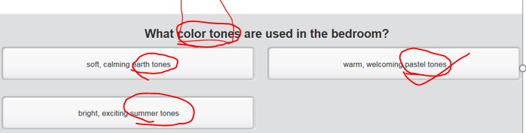

* Oh, your kitchen, very **Fengshui** style. Everything is, just in the right place where it should be. No mess, no dirt. Well, everything is easily **accessible** and **clear of clutter**.  
   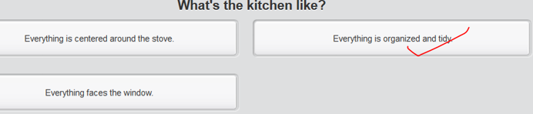
* And this’s your living room? It’s …very small, but I like it. I mean it has friendly feel in it. It definitely feels comfortable**, warm and welcoming.**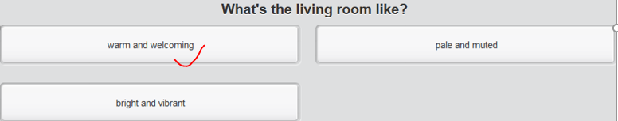

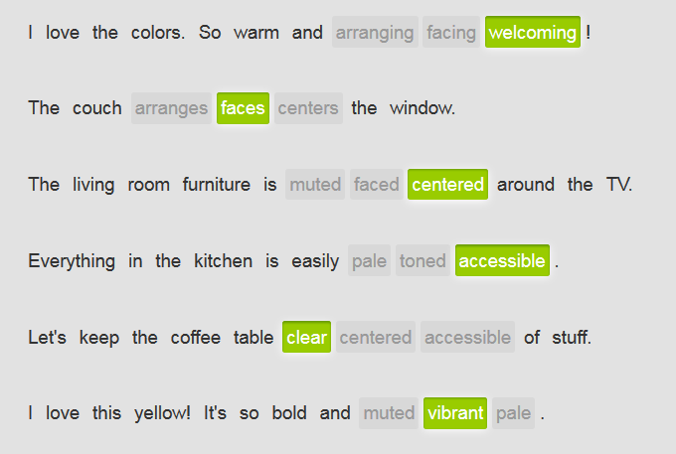

# Part 3) > 2nd row Explain the concept of “abstract”

当有人不熟悉某一抽象概念时，你不能只给人看图来阐释 - 你必须加以解释。首先，使用动词 **be** 介绍它是什么。它是一种系统吗？它是一种做事的方法吗？它是最理想的吗？在下面的例子中，对 **feng shui** 加以定义，然后再定义 **chi** 和 **space**，进一步说明 **feng shui**。

|  |  |
| --- | --- |
| 'Feng shui' **is a system of aesthetics** regarding how things are arranged in a space. | '风水'是一种关于物品在空间如何摆放的**美学系统**。 |
| 'Chi' **is energy**. | 气是能量。 |
| Space **is the open area** available in a room. | 空间是房间中可用的空旷区域。 |

接着，介绍一些历史或背景信息。

|  |  |
| --- | --- |
| Feng shui **was developed** in China more than 3,000 years ago. | 风水 3000 多年前在中国形成。 |
| Space is **one of the fundamental elements** of interior design. | 空间是室内设计的基本元素之一。 |

然后你可以解释这一概念之于你的作用，或你能拿它做什么。使用 **by + -ing** 动词帮助解释。

|  |  |
| --- | --- |
| **By understanding** the theories/principles of feng shui, you can design **a warm and welcoming** home. | 通过了解风水，你可以设计**温馨宜人的**居所。 |
| **By following** the ideas of feng shui, you can create a good flow of energy and bring in good fortune. | 通过遵循风水的理念，你可以打造良好的能量流通，带来好运。 |
| A feeling of freedom or luxury can be expressed **by allowing** large, open spaces. | 设置宽敞而开阔的空间，可以透露一种自由感或奢华感。 |

你也可以提出实例和建议，介绍这种抽象概念是如何在现实生活中作用的。

|  |  |
| --- | --- |
| **One tip for using** feng shui is to keep the bedroom **clear of stuff.** That helps the energy move. | 一个利用风水的建议是卧室内**不要放东西**。那有助于能量流动。 |
| **For example**, if you want the space to feel larger, **get rid of** some of your furniture. | 例如，如果你想让空间感觉更宽敞，那就去掉一些家具。 |
| **Have you seen** pictures of the Forbidden City in China? **Now that's** feng shui. | 你见过中国紫禁城的图片吗？那就是风水。 |

# To print Part 4) > 2nd row

|  |  |  |  |  |  |  |
| --- | --- | --- | --- | --- | --- | --- |
| 大洲、国家、州或城市的名字前不要使用 **the**，除非是复数形式或属于名字的一部分。国家名字中含有定冠词的并不多。请看下面一些例子： | | | | | | |
|  | |  | | |  | |
|  | | *the Netherlands* | | |  | |
|  | | *the Philippines* | | |  | |
|  | | *the United Arab Emirates* | | |  | |
|  | | *the United Kingdom* | | |  | |
|  | | *the United States of America* | | |  | |
|  | |  | | |  | |
| 日期、月份或季节之前不要使用 **the**，除非你是指特定的某天、某月或某个季节。 | | | | | | |
|  | |  | | |  | |
|  | | ***The*** *summer of 2012 was one of the hottest in years.* | | | 2012 年的夏天是多年来最炎热的一个夏天。 | |
|  | | ***The*** *month of May is my favorite season.* | | | 五月是我们最喜爱的季节。 | |
| 使用 **the** 特指已知事物或各方都了解的事物。注意在下例中，**a man** 是如何变为 **the man** 的： | | | | | |
|  | | | | | |
|  | *I saw* ***a man*** *trying to get into the Empire State Building without paying.* ***The man*** *was caught by security guards and thrown out.* | |  | 我看到一名男子不买票就想进入帝国大厦。那名男子给保安抓住，然后撵走了。 | |
|  |  | |  |  | |
| 注意在下面的例子中，如何假定提及的具体事物是已知或为人理解的。 | | | | | |
|  | | | | | |
|  | *I prefer* ***the country*** *because there are no tall buildings.* | |  | 我喜欢乡村，因为乡村没有高楼大厦。 | |
|  | *I couldn't find* ***the museum*** *because of* ***the fog****.* | |  | 由于雾太大，我找不到那家博物馆。 | |
|  |  | |  |  | |
| 在指代自然界独一无二的物体时使用 **the**，比如 **the sun**、**the moon**、**the stars**、**the sky** 和 **the universe**。 | | | | | |
|  | | | | | |
|  | *The average distance from* ***the Earth*** *to* ***the sun*** *is 150 million kilometers.* | |  | 地球到太阳的平均距离为 1.5 亿千米。 | |
|  | ***The stars*** *in* ***the sky*** *were bright and beautiful as we walked along the dark road.* | |  | 天空繁星点点，明亮而美丽，我们走在漆黑的路上。 | |
|  | *How big is* ***the universe****? Nobody knows. In fact, there may even be other universes out there we don't even know of.* | |  | 宇宙有多大？没人知道。事实上，甚至可能存在我们根本都不知道的其他宇宙。 | |

# Part 4)> 3rd row Reading

## Building related words

* **spire /spaɪə/**

1.The **spire** of a building such as a church is the tall pointed structure on the top. **(教堂等建筑物的) 尖顶**  **[ a spire of a building; a spire of a church ]** a church **spire** poking above the trees.…伸出树梢的教堂**尖顶**。

2.N any of the coils or turns in a **spiral** structure (螺旋形结构的)盘管或拐角 => spiral: n. 螺旋；旋涡；螺旋形之物

3.V to assume the shape of a spire; point up 猜想(塔尖的形状); 指向上

* **antenna**/**ænˈtɛnə**/The antennae of something such as an insect are the two long, thin parts attached to its head that it uses to feel things with. 天线；[动] 触角，触须 => **天线杆: radio mast**
* **signs (of a building)**

A sign is a piece of wood, metal, or plastic with words or pictures on it. Signs give you information about something, or give you a warning or an instruction. (建筑物上的)指示牌

* **flagpole**

A flagpole is a tall pole on which a flag can be displayed. E.g. The new China flag was **hoisted**[hɒɪst] up the **flagpole**. 新国旗被升到**旗杆**顶上 [ hoist a flag up the **flagpole**； hoist a **sail** up the **mast** 杨帆(升帆到(船上的)桅杆) V.S h**ei**st [h**aɪ**st] = robbery ]

* **mast /mɑːst/**

1. The masts of a **boat** are the tall, upright poles that support its **sails**帆. (船上的)桅杆，支撑”帆” [ hoist a flag up the **flagpole**国旗升到**旗杆**顶上; hoist a sail up the mast 杨帆(升帆到(船上的)桅杆) V.S. heist [h**aɪ**st] = robbery]

2. **A radio mast** is a tall upright structure that is used to transmit radio or television signals. 天线杆 => **天线: antenna/ænˈtɛnə/**

* exquisite; 精美的

## Other words

* **exquisite**/ɪkˈskwɪzɪt, ˈɛkskwɪzɪt/**CET6 TEM4**

1.ADJ Something that is exquisite is extremely beautiful or pleasant, especially in a delicate way. 精美的 The Indians brought in exquisite beadwork to sell. 印地安人带了精美的珠饰来销售。

2.ADV 精美地 exquisitely ...exquisitely crafted dollshouses.…制作精美的玩具小屋

* **intriguing /ɪnˈtriːɡɪŋ/ , intriguingly**

1. If you describe something as **intriguing**, you mean that it is interesting or strange, arousing your curiosity. 新奇**有趣**的 **[ an intriguing book; an intriguing adventure; an intriguing trip ]** e.g. This **intriguing** book is both thoughtful and informative. 这本新奇有趣的书既有思想性又有知识性.
2. Intriguing = appealing = attractive = charming or gorgeous 迷人的 吸引人的 [ 迷人的 吸引人的笑容**an intriguing/appealing smile ]**

* **appealing /əˈpiːlɪŋ/**

1. Someone or something that is **appealing** is pleasing, **charming**, **gorgeous**, **intriguing**, and **attractive**. 迷人的吸引人的 e.g. There was a sense of humour to what he did that I found very **appealing**/**intriguing**.他所做的带有一种我发现很**迷人的**幽默感。[ 迷人的 吸引人的笑容**an intriguing/appealing smile ]**
2. **An appealing expression, an appealing look, or an appealing tone of voice** indicates to someone that you want help, advice, or approval from them. **恳求的 (表情、语气)** e.g. She gave him a soft **appealing look** that would have melted solid ice. 她向他投去一种会融化坚冰的温柔**恳求的表情**

* **worthwhile**/ˌwɜːθˈwaɪl/**值得花时间去做的**

If something is **worthwhile**, it is **enjoyable** or useful, and is worth your time, money, or effort that is spent on it. E.g. The president's trip to Washington seems to have been **worthwhile**. 该总统本周的华盛顿之行似乎是值得的 e.g. Overall, having a trip in SH and seeing various architecture there are **worthwhile**

## 传达肯定或否定的态度

|  |  |
| --- | --- |
| It's an **intriguing** blend of the old and new style. | 它是新旧风格的**迷人有趣的**融合。 |
| The architecture is **odd/weird**. | 建筑风格很奇怪。 |
| The area is **comparatively/relatively** noisy. | 那一地区**相对比较**嘈杂。 |
| The arches[ɑːtʃ] are **profoundly** beautiful = **stunningly or strikingly beautiful.** | 这些拱门非常迷人。 |
| **I have no doubt that** Shanghai's reputation for innovative architecture will be maintained. | 我**毫不怀疑**上海在创新建筑方面的名声会延续下去。 |
| The **Bund** has **a special place in my heart**. | **外滩**在我心中占据着特殊的位置。 |
| The Temple of the Town God **is genuinely fit for** a heavenly being. | 城隍庙**非常适合**祭祀神灵。 |
| The **Oriental Pearl Tower** makes you feel like you've been kidnapped by aliens. | **东方明珠塔**让你感觉好像被外星人绑架了一样。 |

## Writing about buildings in your country

Describe the **tallest** building**s** or **unusual** architecture.

* Buildings in **your** city or country:

**Buildings/Architectures in Shanghai, China (see the previous session)**

**Buildings/Architectures i**n my city, Xi’an

* Buildings/Architectures in **other countries, in** Seoul, Korea

1. Li Da University: **unusual arch**

2. The memorial of Korea War: take the Loure Palace as my references.

3. Tallest: 603 with spires

**=> Consider SWOT: strength V.S. weakness; Opportunity V.S. threat (like a coin with two side, pros and cons; advantages V.S. downsides)**

## Sample: Buildings/Architectures in Belgium

(Leading sentence, overall architecture style of the city) The historic architecture of Bruges, in Belgium, is **marvelous**. The city is well-known for its Gothic buildings, with their pointed arches and **celebratory** spires, built in **roughly** between the 13th and 16th centuries.

(Describe the typically amazing buildings/architectures in this city: e.g. the most unusual building and the tallest one)

Some of the most **exquisite** 精美的ˈɛkskwɪzɪt/buildings are centered around Market Square, the heart of the city. If you visit Bruges, I recommend you stay in the Grand Hotel, an 18-century building with a **contemporary** wing that blends in beautifully. The hotel is conveniently situated in the center of the old city.

Near the Grand hotel is the **fabulous** City Hall, the oldest city hall in Belgium and the Netherlands. There's also the Church of our lady, which **houses** a lovely Michelangelo sculpture and is also the **tallest** building in the city, counting the spire. The spire itself is 122 meters, amazing.

(Describe a not-so-good buildings/architectures in this city) Here is one modern building worth mentioning: a **somewhat** overwhelming concert hall. Although I'm pleased the city decided to construct something that reflects the current time, the building itself is not all the inspiring, in my opinion.

( Concluding sentence) Overall, however, **I have to double that yo**u will completely enjoy a trip to Bruges and learn much about world history from our unique city.

## My hometown: Buildings/Architectures in Xi'an

**(This topic is a one-size-fit-all for: introduce your hometown, travelling domestically, architectures/buildings in your hometown)**

(Leading sentence, overall architecture style of the city)

The historic architecture of Xi'an, the most ancient city in China, is **spectacular/marvelous**. The city is well-known for its Tang Dynasty architecture, especially marvelous temples with their triangle roof with slopes.

(Describe the typically amazing buildings/architectures in this city: e.g. the most unusual building and the tallest one)

( the most unusual buildings)  Some of the most **exquisite**精美的ˈɛkskwɪzɪt/buildings are centered around Old Temple Tower, the exact heart of the city. These fabulous buildings are with sort of temple appearance, very attractive to visitors. You would feel appealing to have a look the inside of each building. If you visit this area, I highly recommend you stopping by the Starbucks that is housed in the courtyard near the Old Temple Tower. This Starbucks is totally an ancient art. The whole building is like a Chinese template, colored with earth tones, a blend of pale brown and beige. However, you would be astonished by the contemporary paintings inside. What such an amazing cultural conflict, very interesting. It is a must-see spot.

(tallest building) When mentioning the tallest building in XI'an, it's reported that the New Tech Mall, mostly looking like the Petronas Twin Towers in Kuala Lupur, would be the tallest building in Xi'an. When it was initially designed, it clearly aims to be in the running and compete with other tall buildings in Xi'an. Currently, although this building is still under construction,the whole frame is almost finished, which sparks heated controversy about its height because this building features outstanding spires/antennas/signs. The spire is around 8 or 9 meters. Therefore, whether this building would be the winner depends on what criteria are used to measure height.

(Describe a not-so-good buildings/architectures in this city)   
Here is one modern building worth mentioning: a **somewhat** overwhelming concert hall. Although I'm pleased the city decided to construct something that reflects the current time, the building itself is not all the inspiring, in my opinion.

( Concluding sentence)   
In a nutshell/To sum up briefly, I would definitely say that travelling in Xi'an and enjoying historic tastes are pretty worthwhile**.**

## Shanghai arch, building

**Discovering the old and the new**

The buildings of Shanghai are simply **breathtaking** in their size and diversity. The city has an **impressive** number of modern skyscrapers ['skaɪ'skrepɚ] – more than a thousand, according to some counts – that are **in sharp contrast to** several styles of architecture from different time periods.

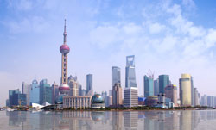

* The **Bund** offers the perfect tour of **sophisticated spectacular** European buildings, many constructed in the mid-1800s to early 1900s in various **gorgeous and exquisite** /ˈɛkskwɪzɪt/精美的  styles, including **Renaissance** ['rɛnəsɑns], **Baroque[bə'rɔk]** and **neo-classical**. The area is **attractively/intriguingly** situated along the Huangpu River. Look across the Huangpu for one of the city's most **intriguing/appealing** architectural contrasts: Pudong, with buildings that look like they belong in a **science-fiction movie**.
* Here, you'll immediately notice Shanghai's most famous building, the **Oriental Pearl Tower**. It's definitely not the world's most beautiful building, but it is one of the tallest (at 468 meters) and most unusual. The **spire [spaɪə] [建] 尖顶；尖塔；螺旋** and **antennas [**æn'tenə] reach an impressive 118 meters high. Near the Pearl is the Shanghai World Financial Center, which, with 101 floors, is China's tallest building.
* Don't miss the former French Concession, which **has a special place in my heart**. The **comparatively**/**relatively** quiet streets are lined with French architecture and **lively/vibrant green** trees. Two favorite buildings are the Little Red House, which used to be a record company and is now a restaurant; an **exquisite**, eight-**story** apartment building that invites you to dream about how the people of Shanghai lived in the 1930s.
* Shanghai's **Shikumen** houses are a **masterful 技艺精湛的 blend of** Chinese and European stone architecture. Each house **features** a large, stone entrance that opens up onto a small **courtyard**.
* The Old City is the best place to see traditional Chinese architecture. Shanghai's **Temple of the Town God** 城隍庙was first constructed in the early 15th century. The temple is topped with the **delicately profound** arches of traditional Chinese roofs.

**All in all/In a nutshell/To sum up briefly,** there's more to Shanghai than meets the eye. Whether you're a slave to modern architectural fashions, or prefer getting lost down traditional tree-lined streets with old buildings to either side, there's something in Shanghai for everyone. Overall, seeing SH architecture is **worthwhile**.



# CNN- architecture related news/podcast

## Stop: Lexical resources

|  |  |
| --- | --- |
| 喧宾夺主，抢了sb 风头 | upstage sb. /steal sb's thunder = If someone upstages you, they draw attention away from you by being more attractive or interesting. e.g. I didn't show up in your birthday party coz I don't wanna steal your thunder/upstage you E.g. Well, the bridesmaid/the maid of honor is strikingly beautiful that she completely steals the bride's thunder in the sumptuous奢华的 wedding party. //bride-to-be: 准新娘; groom-to-be:准新郎 //sumptuous: ['sʌm(p)tjʊəs] is grand and obviously very expensive with luxury taste |
| 使sb相形见绌/黯然失色 | extinguish sb: to obscure; eclipse. eg She was **extinguished** by her sister. 她的妹妹 使她相形见绌 |
| 使sb/sth 黯然失色 | eclipse /ɪˈklɪps/  1. N-COUNT An eclipse of the sun is an occasion when the moon is between the earth and the sun, so that for a short time you cannot see part or all of the sun. An eclipse of the moon is an occasion when the earth is between the sun and the moon, so that for a short time you cannot see part or all of the moon. (日、月) 食 **lunar eclipse V.S. the solar eclipse日食**  2. V-T If one thing is eclipsed by a second thing that is bigger, newer, or more important than it, the first thing is no longer noticed because the second thing gets all the attention. 使sb/sth 黯然失色 e.g. ...the space programme has been e**clipsed** by other desperate needs. …这项太空计划和其他的紧迫需要相比已经黯然失色了。 |
| 因自身巨大而〕使显得矮小，使相形见绌 | dwarf [dwɔːf] n. 侏儒，矮子 vt. 使矮小 adj. 矮小的 复数 dwarfs或dwarves 1. an imaginary creature that looks like a small short man 小矮人〔虚构的人物〕Snow White and the Seven Dwarfs 《白雪公主和七个小矮人》 2. a person who is a dwarf has not continued to grow to the normal height because of a medical condition. Many people think that this use is offensive. 矮子，侏儒〔许多人认为这一用法具有冒犯性〕 →white dwarf 3. a dwarf plant or animal is much smaller than the usual size 〔植物或动物〕矮生的 a dwarf conifer 矮生针叶树 v) dwarf sb/sth: to be so big that other things are made to seem very small 〔**因自身巨大而〕使显得矮小，使相形见绌** e.g. The cathedral is dwarfed by the surrounding skyscrapers. 周围的摩天大楼使得大教堂显得很矮小 |

* futuristic /ˌfjuːtʃəˈrɪstɪk/

1. Sth that is futuristic looks or seems very modern and unusual, like something from the future. 未来派的 e.g. The theatre is a futuristic steel and glass structure. 是一座未来派的钢筋玻璃结构建筑。

2. **A futuristic film/ book** tells a story that is set in the future, when things are different. 科幻 (影片,小说，书) = science fiction e.g. ...the **futuristic** hit/sensation film, "Terminator 2." …轰动一时的**科幻电影**《终结者2》。

* mirage /mɪˈrɑːʒ/

1.N-COUNT A mirage is something that you see when it is extremely hot, for example in the desert, and which appears to be quite near but is actually a long way away or does not really exist. 海市蜃楼; 幻境 [ desert mirage 沙漠海市蜃楼] e.g. It hovered before his eyes like the mirage of an oasis. 它在他眼前晃动，好像海市蜃楼里的绿洲。

2.N-COUNT If you describe something as a mirage, you mean that it is not real or true, although it may seem to be. 幻想; 妄想 illusion e.g. The girl was a mirage/illusion, cast up/envisioned想像 by his troubled mind. 那个女孩是他的幻觉

* edge out sb: 险胜sb, 微微胜过sb;  挤掉sb

e.g. Wuhan Greenland Center, Wuhan, China – China-based Greenland Group is developing five of the 100 tallest towers currently under construction, including the leader of the pack racing toward a 636-meter summit. Unless Jeddah Tower mounts a **miraculous** late surge, Wuhan Greenland will **edge out Shanghai** Tower for World #2 when it tops out next year.

=》

* 超过; 赶超(某人，某个国家，竞争对手）over => **overtake sb; overtook ,** overtaken (esp a competitor [kəm'petɪtə]) = catch up with sb and go beyond that person 1. If someone or something overtakes a competitor, they become more successful, more impor他ant, more serious than them.
* thought-provoking (书籍、电影等)发人深省的; 引人深思的

1.ADJ If something such as a book or a movie is thought-provoking, it contains interesting ideas that make people think seriously. e.g. This is an entertaining yet **thought-provoking film**. 这部电影令人捧腹，却又发人深省。

* A livable city, an inhabitable city e.g. "We've seen a **skyrocketing**/**hiking** rise in property prices, there's an increasing population and people tend to live on their own, not in big families. This all requires architects to look at how small houses can be made more **livable/inhabitable适于居住**."
* “at a premium” e.g. With space **at a premium** in HK.
* 非正统的; 另类的 Unorthodox: if you describe someone's behaviour, beliefs, or customs as **unorthodox**, you mean that they are different from what is generally accepted. E.g. The reality-based show followed the **unorthodox lives** of Ozzy, his wife Sharon, daughter Kelly, and son, Jack. 另类生活   
  e.g. The lack of available land suitable for building on, coupled with **notoriously/disreputably** restrictive building regulations, means that **unorthodox [ʌn'ɔrθə'dɑks]非正统的; 另类的** architectural visions are rarely realized in Hong Kong.
* envisage**[in'vizidʒ]** sth/envision sth/imagine sth   
  e.g. In second place, "[Vertical Village](https://hongkongpixelhomes.beebreeders.com/#p2)" saw French architect Maria **envisages[in'vizidʒ]/envision/imagine** multi-story homes with internal roofs and large glass fronts. "Sometimes (in Hong Kong) you find very tiny apartments where the toilet and kitchen are in the same place. It can be better to live vertically. We wanted to give people more space -- and more open space."
* sphere, hemisphere, atmosphere/vibe, **troposphere, ['trɔpəusfiə, 'trəu-] [气象] 对流层**, the lowest atmospheric layer; from 4 to 11 miles high (depending on latitude)
* boulder /ˈbəʊldə/  V.S. pebble 鹅卵石

A boulder is a large rounded rock. 圆形巨石 e.g. It is thought that the train hit a boulder that had fallen down a cliff on to the track. 列火车撞到了从悬崖滚到铁轨上的大圆石。

* Status V.S. liberty of statue['stætʃu] V.S. statute, statutory(a)，[ statutory holiday 法定假期]

statute /ˈstætjuːt/

1.N-VAR A statute is a rule or law which has been made by a government or other organization and formally written down. 法令; 规章 e.g. The new statute covers the care for, raising, and protection of children. 这项新法令涵盖了儿童的照料、养育和保护

statutory /ˈstætjʊtərɪ/

1.ADJ Statutory means relating to rules or laws which have been formally written down. 规定的; 法定的 e.g. The FCC has no statutory authority to regulate the Internet. 美国联邦通信委员会没有规范因特网的法定权力

* contemporary /kənˈtɛmprərɪ/

1.ADJ Contemporary things are modern and relate to the present time. 当代的 [ contemporary art ] e.g. She writes a lot of contemporary music for people like Whitney Houston. 她为惠特尼·休斯敦等人创作大量当代音乐作品。

2.ADJ Contemporary people or things were alive or happened at the same time as something else you are talking about. 同时代的 e.g ..drawing upon official records and the reports of contemporary witnesses.

…借助官方记录以及当时目击者的证言。

3.N  Someone's contemporary is a person who is or was alive at the same time as them. 同时代的人 e.g. Like most of my contemporaries, I grew up in a vastly different world. 像我**同时代的大多数人**一样，

## Nice: Bund in SH

<http://edition.cnn.com/style/article/fosun-foundation-bund-finance-centre/index.html>

In Shanghai's historic Bund district, visitors circle a new theater with a **brash碎片** -- and slowly rotating -- veneer of bronze-colored steel bamboo. Beside it, a pair of recently completed 590-foot-tall towers overlook the city's colonial-era buildings and the financial district just beyond.

These new structures form part of the Bund Finance Centre, a 4.5-million-square-foot collaboration between British architectural giants Heatherwick Studio and Foster + Partners. The development is rapidly transforming an area that is also known for its **staunchly** unwelcoming office buildings.

**For now**, however, it's the bronze-colored theater that is proving popular with riverside tourists.

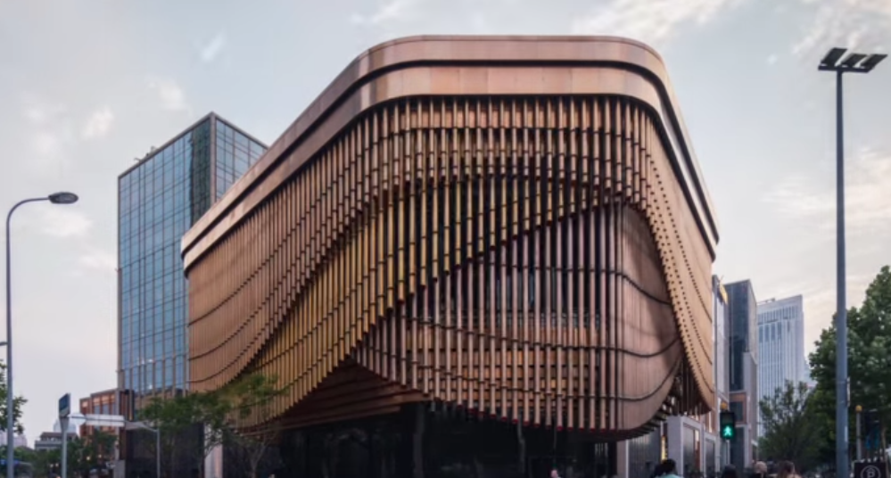 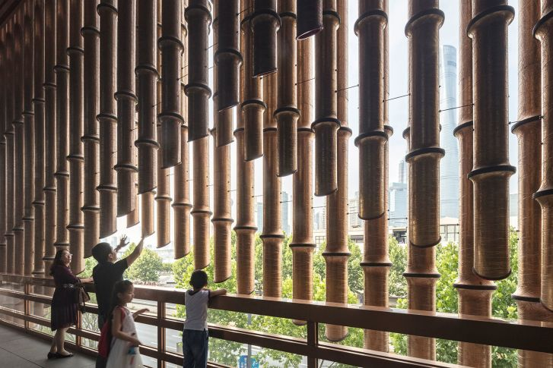 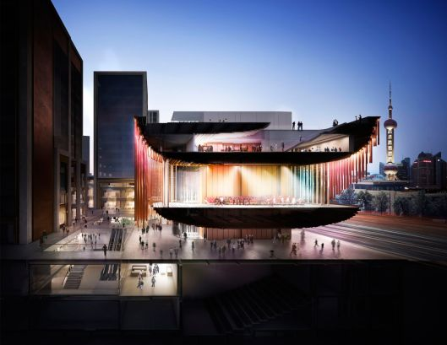

Dividing opinions

Known as the Fosun Foundation, the **squat**, edgeless building is quirkily **incongruous**. Three layers of **stainless steel** piping slowly move on electric-motor tracks, readjusting over the course of a few minutes to reveal glimpses of glass windows and the second floor's golden **balcony**.

Approaching the building's ground floor, it is unclear where to enter the structure. The outside **patio** seems to merge **seamlessly** with the stone floor inside. But find your way in, and the space opens up to reveal a lobby, **atrium** and cafe, the upper floors paying homage to the open-air stages of traditional Chinese theaters.

The Fosun Foundation, by Foster + Partners and Heatherwick Studio, is **inspired** by the open stages of traditional Chinese theaters. Credit: Laurian Ghinitoiu

Although only four stories above ground, the Fosun Foundation reaches a further four floors beneath it. The **basement** levels host several echoing **auditoriums** and a series of white-walled **hallways** that will connect the building with **the adjoining complex**.

Heatherwick Studio founder, Thomas Heatherwick said his team was influenced by "the materiality and scale" of existing historic buildings along the city's famous Bund.

The building's **facade [fə'sɑːd]/outlook/appearance 正面；表面；外观** of metal tubes rotates over the course of a few minutes. Its three layers of bronze-colored steel piping slowly readjust to reveal glimpses of glass windows and a golden **balcony**. **Scroll through the gallery** to see impressive cultural spaces from around the world.

"The opportunity to make something new in this prominent location that had formerly been the river gateway to Shanghai's Old Town was extraordinary," Heatherwick said in a **press release**.

"With a project that would create 420,000 square meters of space, we felt a great duty to look for fresh ways to connect with China's amazing built heritage and make a meaningful public place for thousands of people to work and come together."

Other architects offer differing views on the new theater and arts center, like "**The market is saturated**, so developers are reaching for more creative approaches that add extra value -- value that isn't necessarily economic," said Miguel Bispo of David Chipperfield Architects, a firm that has also worked on developments in the Bund district.

"It is common to hire a specific architect because of their name. That's one way to add value. But this [the Fosun Foundation] is an emotional value -- something that stands out. That metallic facade will be photographed a million times."

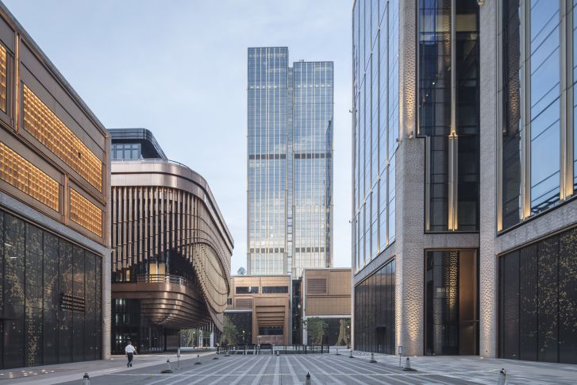

Ben Wood, the American architect behind Shanghai's famous Xintiandi district, is less **complimentary/flattering没有那么恭维**."It doesn't have anything in common with anything on the Bund," he said. "The great thing about the Bund is that it's **majestic**[mə'dʒestɪk] 庄严的；宏伟的. They wanted a building that stands out and says that their company is progressive. But it's not majestic. 'Iconic' is just a generic word for something that stands out.

A growing arts district

The eight-building Bund Finance Centre is one of a number of new developments in the neighborhood. And with a **state-sponsored** art zone blossoming directly to its south, the Fosun Foundation may become the face of an increasingly dynamic district.

//dwarf sth: to be so big that other things are made to seem very small 〔因自身巨大而〕使显得矮小，使相形见绌

Beijing's arts scene has traditionally **dwarfed** those found other Chinese cities, but Shanghai's municipal government has long been cultivating the city's image as a cultural hub. In their latest "Five-Year Plan," Shanghai authorities established the West Bund Group, a state-owned enterprise with a 660-million-yuan **endowment(sponsor funding)** to develop a new arts district.

The injection of government investment has spurred/stimulated cultural initiatives like the West Bund Art and Design Fair, one China's biggest art fairs, which opens for its fourth annual edition later this week.

"This year, Shanghai started a big effort to link up five districts along the Huangpu River into one waterfront area. As both an economic and cultural center, Shanghai will play an important role in the art trade and the exhibition of arts in the coming years."

Long-term investment has already **paid off取得成功/取得了回报**, bring lots of amazingly awesome change here, according to Swiss artist, who founded the city's first privately owned gallery, ShanghART, in 1996.

"The (new art districts) can all be seen as steps towards building a more creative, **livable/inhabitable** and enjoyable city," he said. "Twenty years ago, we used fish wire to hang paintings and neon lights to illuminate them. But **nowadays**, the standards and expectations for exhibitions have been transformed."

Bund Finance Centre's co-designer Thomas Heatherwick has been a regular fixture in China since 2010, when his "Seed Cathedral" was named top pavilion at the Shanghai World Expo. Norman Foster's firm Foster + Partners, also has a significant footprint in China's cities. But this new Shanghai development marks the first major collaboration between two of the great forces of contemporary architecture.

"They have different profiles," said Bispo. "Foster + Partners is a mega office with more than 1,000 people. It's very corporate. Heatherwick is more of a boutique office with focus on tailored design.

"In a way, **they complement each other**. The Foster office is too big to give such a personalized design but technically they are very good. Heatherwick can give a special design and 'face' to a project."

Quite what Shanghai makes of this new riverside face remains to be seen. But with the Fosun Foundation now open to the public, this development -- and others in the district -- are already igniting discussions in China's arts scene and beyond.

## 9 innovative contemporary 当代的 buildings that test the limits of humble brick

<http://edition.cnn.com/2017/07/25/architecture/best-brick-buildings-architecture/index.html>

hotos: The world's best contempory brick buildings

The Switch House by Herzog & de Meuron (London) – Opened in 2016, the new wing of the Tate Modern, which includes both over- and underground galleries -- expanded the museum's gallery space by 60%.

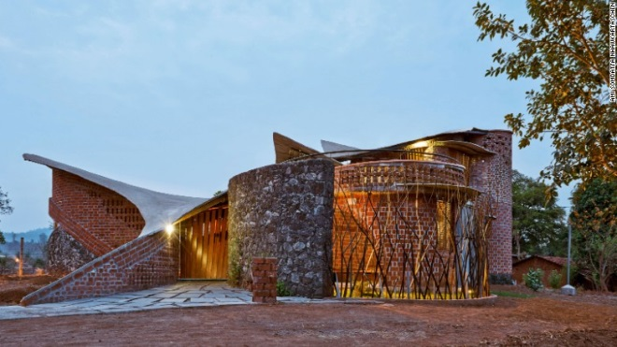

The world's best contemporary brick buildings – A new book by Tachen explores some of the most awe **inspiring** brick buildings from around the world, from residential homes in Vietnam to the Tate Modern Switch House in London these contemporary builds show how the brick has stood the test of time.

## **Futuristic** skyscraper ['skai,skreipə] 未来派的；未来主义的

<http://edition.cnn.com/2017/03/29/living/analemma-tower-orbiting-skyscraper-trnd/index.html>

Feeling too fancy for normal earth-bound existence? A new skyscraper concept would elevate your living situation -- literally. [Clouds Architecture Office](http://cloudsao.com/) has [unveiled plans](http://www.cloudsao.com/ANALEMMA-TOWER) for a **futuristic [,fju:tʃə'ristik] 未来派的；未来主义的** skyscraper dubbed the "Analemma Tower." The building would hover **majestically** above the ground because it would be attached -- wait for it -- to an actual **asteroid/ˈæstəˌrɔɪd/小行星** , in space, that is forcibly put into orbit around the Earth.

The tower will be suspended via high-strength cabling from an **asteroid/ˈæstəˌrɔɪd/小行星** and placed in "eccentric geosynchronous orbit". In other words, it would be always moving -- residents and visitors would take a daily journey between the northern and southern **hemispheres** with a prolonged visit over a main "home" point like New York City or Dubai

In 2015 the European Space Agency's [Rosetta Mission](http://www.cnn.com/2016/09/30/health/rosetta-landing-comet-philae/) successfully landed on the surface of the comet showing that it is possible to interact with such smaller bodies in space. [NASA's "Asteroid Redirect Mission"](http://www.cnn.com/2016/09/05/health/osiris-rex-nasa-asteroid-mission/) is scheduled to send a robot to collect a **boulder**圆形巨石 off an **asteroid/ˈæstəˌrɔɪd/**小行星 and then place that **boulder**圆形巨石into a stable orbit around the moon.

//卵石 pebble V.S.  A **boulder** is a large rounded rock. 圆形巨石

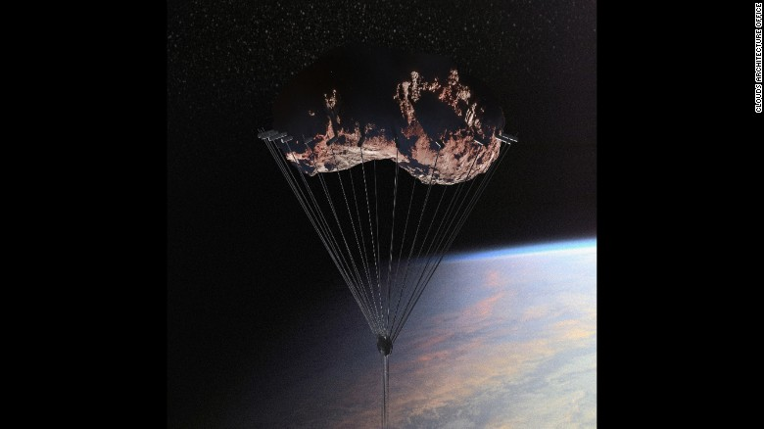

An **asteroid** is relocated into a geosynchronous orbit and **affixed with** supporting cables to hold the tower below. In like fashion, CAO plans to use an asteroid **that is harnessed with** high strength cabling reaching towards earth to hold the skyscraper along its journey. //safety harness 背带

Analemma Tower's designer told CNN that the tower could be made of **durable耐用的，持久的 and lightweight material**s such as carbon fiber **and aluminum [ə'lju:minəm**]. Advances in cable engineering would be needed to achieve the cable strength required to support the structure. Power would come from space-based **solar panels** that have a constant exposure to sunlight, which is one of the most **sought-after吃香的/受追捧的** **renewable energies**.

Water for the tower will be captured from clouds and rainwater and maintained in a semi-closed loop system. As proposed the top of the tower sits at 32,000m and would be expected to reach speeds of 300mph as it travels through the sky.

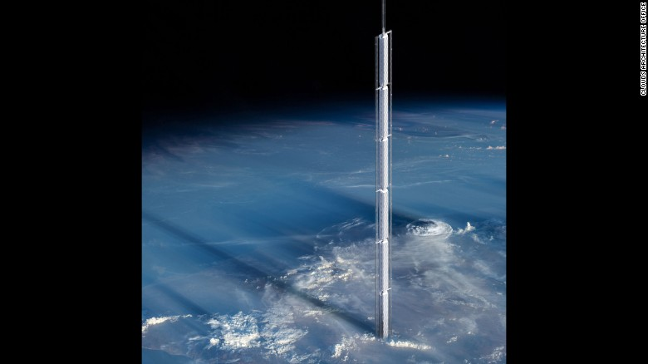

The upper reaches of Analemma would extend beyond the **troposphere, ['trɔpəusfiə, 'trəu-] [气象] 对流层**, the lowest **atmospheric** layer; from 4 to 11 miles high (depending on **latitude V.S. longitude** 经度)

If you have to ask these questions then, we hate to say it, you are probably not ready to live in a huge mobile asteroid**/ˈæstəˌrɔɪd/小行星** tower, but the designers have your back **nonetheless**.

## Construction in China's 'skyscraper ['skai,skreipə] capital' shows little sign of slowing

It rises like a **mirage [mə'rɑʒ]  海市蜃楼；幻想** as you pass the fallow fields and fish ponds of outer Hong Kong: a wall of skyscrapers **shimmering/twinkling** in the distance. This is Shenzhen, which has grown from a small fishing village into a major financial and technology hub in less than 40 years.

Like many other cities in China, Shenzhen is crazy for skyscrapers. Of the 128 buildings over 200 meters tall that were completed in the world last year, 70% were in China, according to the [Council on Tall Buildings and Urban Habitat (CTBUH](https://www.skyscrapercenter.com/city/shenzhen)). Shenzhen was responsible for 11 of them -- more than the entire United States, and almost twice as many as any other Chinese city (Chongqing and Guangzhou tied for second place, alongside Goyang in South Korea, with six skyscrapers each).

Tall by design

The city's relationship with high-rises goes back to 1980, when China's **reformist** leader, Deng Xiaoping, declared that a swath of farmland along the Hong Kong border would become a so-called Special Economic Zone. The decision meant that companies could operate with fewer of the restrictions of a planned economy -- China's first major experiment with free markets since the **Communist revolution** of 1949. Investors from Hong Kong -- and beyond -- rushed across the border to build factories and other businesses.

From the beginning**, urban/city planners** decided that it would be a city of skyscrapers. Shenzhen's growing skyline is simply part of its DNA, according to University of Hong Kong architecture professor Juan Du, whose book, "The Making of Shenzhen: A Thousand Years in China's Instant City," will be published next year. "In Shenzhen, (skyscrapers are) really linked to the image and brand of the city. Between the early 1980s and the early 90s, it had more tall buildings than any Chinese city. "The term 'Shenzhen speed' was coined from the (time of) the construction of the city's earliest skyscrapers. When Deng Xiaoping made his first visit to Shenzhen, he was really excited by the speed at which tall buildings were being built."

[MahaNakhon: Why Asia's **futuristic未来主义的/  科幻性的 (影片、书)** skylines just got crazier](http://edition.cnn.com/2016/06/30/architecture/ole-scheeren-bangkok-skyscraper/index.html)

Today, Shenzhen has **evolved** beyond its manufacturing roots to become a hub for service industries -- especially technology and design. Often described as "China's Silicon Valley," the city **is home to** huge companies like Tencent (which itself built two skyscrapers) and a network of thousands of smaller firms.

But Shenzhen's geography plays a part, too: the city center is located in a narrow strip between mountains and the Hong Kong border. A growing network of subway lines and a new high-speed rail connection to Hong Kong have made this strip even more desirable, pushing development up rather than out.

Shenzhen appears to be showing no signs of slowing. In addition to a current crop of 49 buildings taller than 200 meters, a further 48 skyscrapers are under construction, according to CTBUH data.

## Japan's 'nature architecture' has deep cultural roots

<http://edition.cnn.com/2017/06/13/world/japan-nature-architecture/index.html>

In Japan, the line between nature and the built environment is a blurred one and the country's leading architects are using this concept to create innovative and cutting-edge designs.

Sou Fujimoto is at the forefront of Japan's forward-thinking design and is known for integrating nature into his work. His designs include cloud-like structures like the futuristic Serpentine Pavilion, in London, and a glass, transparent house in Tokyo inspired by the life of a tree.

Another celebrated architect, Toyo Ito has twice won the prestigious Pritzker Prize, and it's no coincidence that some of his most inventive works are designed to be experienced like forests.

His Mikimoto Ginza, Tod's Omotesando and Sendai Mediatheque incorporate tree-like elements, and light falls into the buildings like it would a forest.

Nature in buildings

While the designs are forward-looking, they have their origins in a tradition deeply rooted in Japanese culture, where architectural practice has always been to work in harmony with the natural surroundings. Buildings are built around trees, in trees and as trees.

It's difficult to know when this philosophy began. It has "always been there," says Neil Jackson, an expert on Japanese architecture from the University of Liverpool in London.

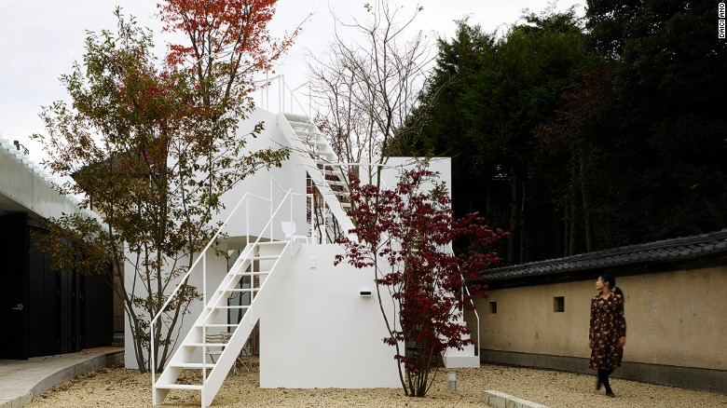

This house designed by Sou Fujimoto mirrors a porous mountain. Large trees dwarf small minimalist blocks.

However, one clue can be found in the Japanese writing system. Put together the pictogram (Kanji) for "house", and the pictogram for "garden," and you get "home." The space inside and outside the building is continuous.

The source of this approach is, in many ways, a result of Japan's mountainous landscape and exposure to extreme weather events, like earthquakes, which thrusts nature to forefront of daily life. As such, the country has limited spaces for living, with most of the population on the coast.

"People's relationship to nature is very immediate. People are very crammed in," Jackson explains.

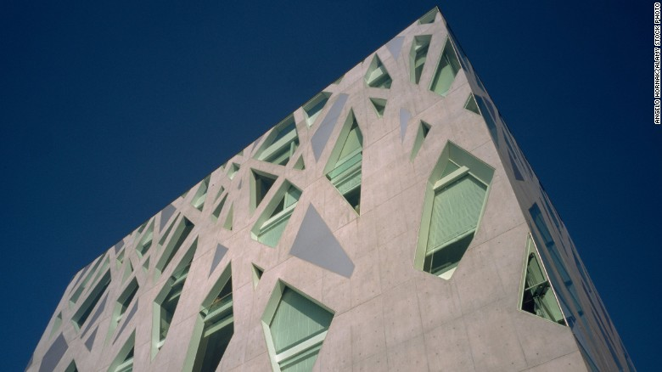

Toyo Ito's tree-like TODS Omotesando Building.

In some cases, traditional rural buildings can be opened entirely to the surroundings. "Japanese buildings often don't have doors. When the weather is very hot, especially in poorer communities in Japan, they would just open up the entire building. Nature flows through the living space," Jackson says.

Finding nature in cities

In contemporary Japan, over 90% of the population lives in urban areas. But even in the country's dense, futuristic concrete jungles the relationship to nature exists.

"Japanese urban living is quite tight and condensed," says Jackson. "Yet within these very tight plots you get extraordinary open situations almost as if there's no container, or containment, at all."

Resilient architecture

The relationship between nature and buildings is also about survival. Buildings can be very lightweight, raised above the ground and flexible to twist and absorb the shock of an earthquake.

Ito's acclaimed Sendai Mediatheque building, in Miyagi, survived the devastating quake of March 2011, in part because of the innovative use of tree-like flexible supporting tubes within the building.

Jackson comments: "There's a huge ability in Japanese culture to survive disasters."

Tadao Ando is a self-taught architect highly regarded for his contribution to modern Japanese architecture. He creates mostly concrete, sculptural buildings that focus on the flow of natural light. Jackson explains: "His work, despite using concrete, reflects that same fizzling of nature and building. Nature is also caves and spaces within the land."

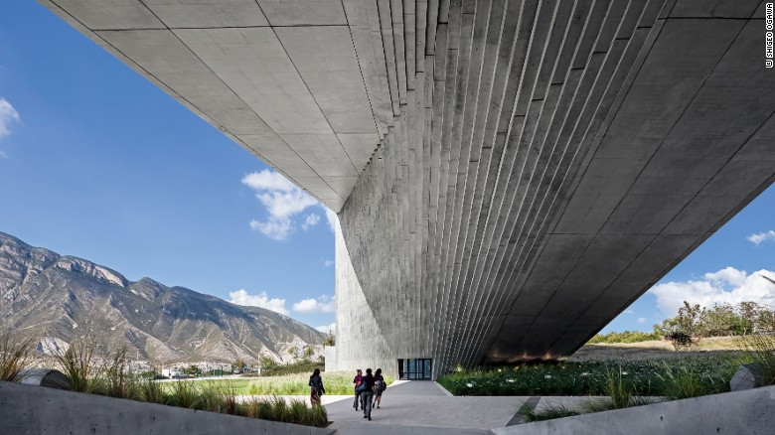

The Center for Arts, Architecture and Design in Monterrey, Mexico, by Tadao Ando.

Japan's culture of resilience is built into its architectural practice, and its ideas about openness translate to even the most modern forms of urban living.

In Japanese thinking there is no built or natural environment -- just nature

# STOP CNN-Arts related news/podcast

# <https://edition.cnn.com/style/article/architect-cesar-pelli-death/index.html> =>the designer of 双子星塔（位于马来西亚吉隆坡 **Kuala Lumpur) [ Petronas Twin Towers /əʊ/]**

## <http://edition.cnn.com/2017/08/08/arts/paleoart-visions-of-the-prehistoric-past/index.html?iid=ob_lockedrail_topeditorial>

Paleontology[,pæiliɔn'tɔlədʒi, ,pei-]n. 古生物学 may be considered a science, but there's an art to it nonetheless. With fossils raising countless unanswered questions -- from dinosaurs' temperaments to the texture of their skin -- attempts to envisage prehistory have always involved elements of guesswork. And for almost 200 years, paleoart has been filling the gaps in our knowledge.

[Dinosaur skulls and mammoth tusks: Antique oddities target new collectors](http://edition.cnn.com/2017/04/02/luxury/sothebys-cabinet-of-curiosities/index.html)

By piecing together available science and their own creativity, paleoartists have enraptured generations of dinosaur lovers. But their artwork also offers insight into the science and art of their day, according to a new book on the subject.

["Paleoart: Visions of the Prehistoric Past"](https://www.taschen.com/pages/en/catalogue/art/all/03421/facts.paleoart_visions_of_the_prehistoric_past.htm) explores the history of paleoart, from 19th century engravings to bold Soviet-era oil paintings.

A collaboration between writer Zoë Lescaze (who previously worked as an archaeological illustrator) and painter Walton Ford, the book charts how portrayals of dinosaurs have evolved since the birth of paleoart in the 1830s.

[Read: 5000-year-old art that you can wear](http://edition.cnn.com/2016/08/03/arts/south-africa-rock-art-street-art-tattoo/index.html)

An 1857 engraving by François Pannemaker, for instance, shows two serpentine dinosaurs -- one with a devilish forked tongue -- facing off as volcanos erupt in the background. Meanwhile, post-war paleoartists like Ely Kish, who painted dinosaurs for the Canadian Museum of Nature, opted for hyper-realism informed by the latest research.

Despite the artworks' diversity, every vision of the prehistoric world serves to remind us of two things: humans' capacity for imagination and the limits of our knowledge.

## <http://edition.cnn.com/2017/07/25/arts/oliver-giles-vr-art/index.html>

This summer in Italy, you can come face-to-face with Jesus.

Towering above you, his sinewy arms will stretch out for crucifixion. His glowing body will convulse sporadically, shooting off showers of golden embers.

But this isn't the second coming -- it's a piece of virtual reality art by the German-Danish artist Christian Lemmerz.

Titled "La Apparizione" (The Apparition), the artwork will be presented in an empty three-by-three-meter room. Viewers step inside, slip on a VR headset and are transported into outer space, where they can circle the levitating, golden Jesus.



It is one of two virtual reality works being exhibited by the Faurschou Foundation in Venice this summer. The gallery joins a growing list of institutions that have exhibited VR art, including New York's Museum of Modern Art and the Whitney Museum of American Art.

And as the world's top curators embrace this new medium, collectors are starting to circle.

[Read: Decoding the thrilling world of digital art](http://edition.cnn.com/interactive/2016/07/style/decoding-the-thrilling-world-of-digital-art/)

Determining value

You might not be able to hang "La Apparizione" on your wall like a painting, but it is most definitely for sale. Lemmerz has released five editions, each costing around $100,000.

But valuing virtual art poses a new a challenge for buyers and sellers alike. Galleries normally look to artists' previous work when setting prices, but with only a small number of VR artworks on the market, there are only a few precedents to refer to.



Comparisons with other types of art do not always prove useful. Lemmerz is primarily a sculptor, but can "La Apparizione" be compared to his 2013 bronze sculpture of Jesus?

The latter work is an object, the former an experience. And while artists have been making bronze sculptures for millennia, virtual reality is a brand new technology more familiar to gamers than art collectors.

The market is still adjusting, according to Sandra Nedvetskaia of Khora Contemporary, the production company that helped Lemmerz create his latest VR art.

"At the moment, video art works are the only comparison," she said over the phone. "But (some collectors) have likened (virtual reality artworks) to sculptures because, of course, you find yourself in the middle of that particular artist's moving sculpture."

[[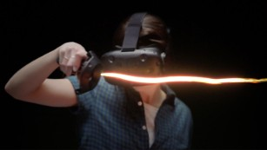](http://edition.cnn.com/2016/05/09/arts/google-tilt-brush/index.html)](http://edition.cnn.com/2016/05/09/arts/google-tilt-brush/index.html)

[Google Tilt Brush: Impossible now a reality?](http://edition.cnn.com/2016/05/09/arts/google-tilt-brush/index.html)

Hardware is another new consideration for galleries, and those selling VR art often include a headset in the price. Nedvetskaia said that all works produced by Khora Contemporary come with HTC Vive headsets -- and a lifetime service.

"That includes updates," Nedvetskaia added, "so that this artwork doesn't become (like) a video tape that you can no longer experience."

But the speed at which VR technology is changing can be a problem for artists, according to Edward Winkleman, who co-founded of the video-oriented art fair, Moving Image, in 2011.

[Read: From selfies to virtual reality, how technology is changing the art world](http://edition.cnn.com/2016/06/13/arts/marc-spiegler-cnn-style-guest-editor/index.html)

"Whether they should wait for the hot, new head-mounted display is a constant question in their practice," Winkleman says. "If they wait, they can take advantage of the new upgrades. But they may (also) miss an opportunity to present their work."

An emerging market

Young artists are experimenting with virtual reality -- and not all of their works carry the six-figure price tag of "La Apparizione," according to Murat Orozobekov, the other co-founder of Moving Image.

"Primal Tourism: Island" by Jakob Kudsk Steensen (2017)

Notable VR works at this year's fair included a swirling, psychedelic piece by up-and-coming digital artist Brenna Murphy, and "Primal Tourism: Island," which took viewers inside Jakob Kudsk Steensen's dystopian vision of a Polynesian island.

"Prices range from about $2,500 to $6,500 for an emerging artist's work," Orozobekov said over the phone.

[Read: Art duo create 3D miniatures of historic events](http://edition.cnn.com/2017/05/24/arts/the-spaces-3d-miniature-art/index.html)

At the other end of the market, a disturbing VR piece by American artist Paul McCarthy is currently available at two major European galleries -- Hauser & Wirth and Xavier Hufkens -- for approximately $300,000. Set in a lurid room, the work features a group of female characters who taunt each other, and, occasionally, the viewer.

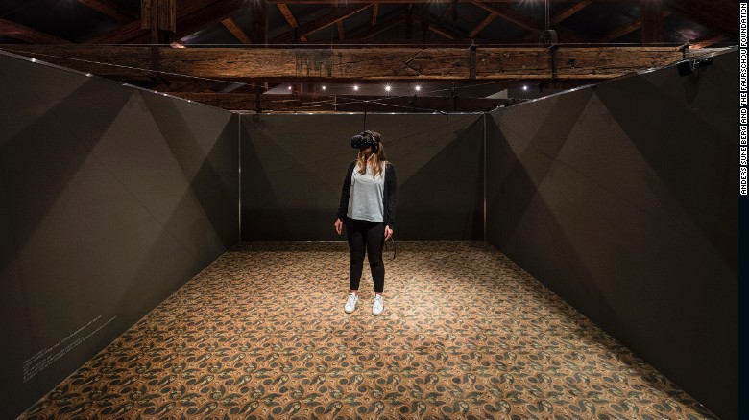

"La Apparizione" by Christian Lemmerz and "C.S.S.C. Coach Stage Stage Coach VR experiment Mary and Eve" by Paul McCarthy are both presented in three-meter by three-meter rooms.

The difference in asking prices is not simply a matter of reputation, according to Elizabeth Neilson, director of The Zabludowicz Collection in London.

"(There's also) the development costs of the technology they have used. Someone like Rachel Rossin does a lot of the development herself, but someone like Jordan Wolfson does none of the technological work himself, and outsources to Hollywood professionals," Neilson said, referencing two up-and-coming artists who have been working in virtual reality. "As you can imagine, this is expensive."

Threat of piracy

The price of virtual artworks can be kept high by limiting the number of copies made. McCarthy's VR piece was only released in an edition of three, and Lemmerz's in an edition of five.

[Read: Artist JR hides the Louvre in plain sight](http://www.preview.cnn.com/2016/05/24/arts/jr-louvre/index.html)

By deliberately restricting supply, galleries create a market for virtual reality art that is based on scarcity -- as with paintings and sculptures. But unlike other art, virtual reality pieces are infinitely replicable. In their most basic form, they are simply digital files that can be experienced by anyone with a VR headset.

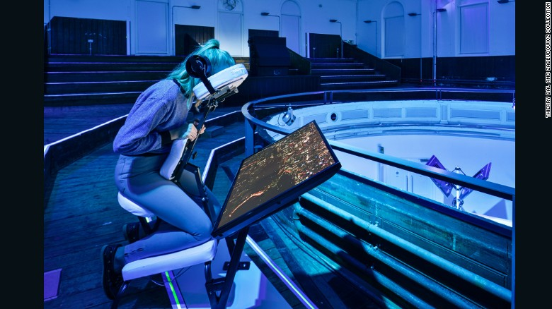

A visitor experiences Jon Rafman's "Tokyo Red Eye (Massage Chair)" (2015) at the Zabludowicz Collection in 2015.

While an artist can easily limit the editions of a sculpture, it is much harder to curb the spread of a digital file -- something that the music and movie industries discovered the hard way. But this presents opportunities as well as threats, according to Nedvetskaia.

"In five years' time every single one of us might have a set of virtual reality goggles in addition to our iPhone," she said. "So don't rule out the possibility that editions of virtual reality artworks might be made at an affordable price so the public can view them. We're really on the cusp of this market being born right now -- the possibilities are limitless."

The art world establishment is yet to fully embrace digital art. Neither Christie's nor Sotheby's have sold a VR work. But both have expressed cautious interest in the medium.

[[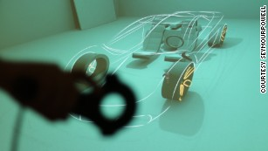](http://edition.cnn.com/2017/07/13/autos/seymourpowell-virtual-reality-car-design/index.html)](http://edition.cnn.com/2017/07/13/autos/seymourpowell-virtual-reality-car-design/index.html)

[This new virtual reality tool could transform how we design cars](http://edition.cnn.com/2017/07/13/autos/seymourpowell-virtual-reality-car-design/index.html)

In March this year, Sotheby's became the first major auction house to exhibit virtual reality art. Hosted at its New York headquarters, the technology-focused exhibition "Bunker" featured "La Apparizione" and a VR work by Sarah Rothberg called "Memory/Place: My House."

Christie's chief marketing officer, Marc Sands, believes that it is only a matter of time before VR starts appearing at major auctions.

"Response to (virtual reality art) from both consignors and buyers is largely positive but to date we have not discovered the 'killer' version of VR," Sands said. "However, as with many things digital, it will come sometime soon."

<http://edition.cnn.com/2017/03/27/arts/ambiguously-yours-hong-kong/index.html>